​​ 

**Lab 4 Deliverables**

Lab Group Z35

Group Name: Bit Legion

Lab supervisor: Goh Tong Hai

Group Members:

|  |  |
| --- | --- |
| **Name** | **Matriculation No.** |
| Adam Tan Jun Xiang | U2120309H |
| Sandhiya Sukumaran | U2120682B |
| Thomas Emmanuel Mathew | U2123204K |
| Khoo Jia Xuan Mavis | U2121376B |
| Ie Jia Sheng | U2122557E |
| Nguyen Gia Khanh | U2120680J |

## **Testing**

## **A) White Box Testing**

**Test case 1: Creating an account**

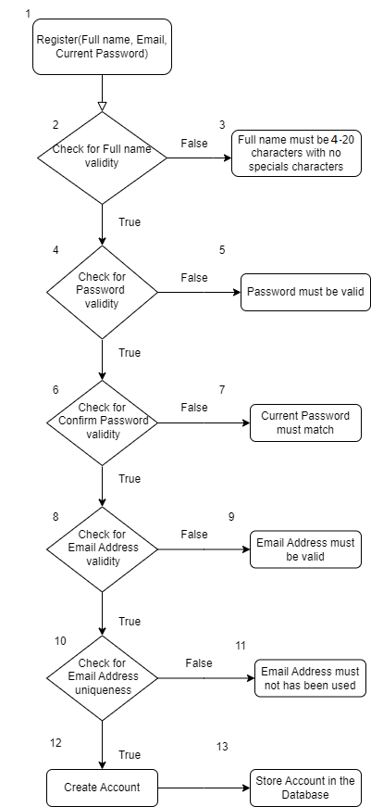

**Test case**

1. The user creates an account with all fields being valid.
2. The user enters an invalid name (use a special character or use under 4 characters or over 20 characters).
3. The user inputs a valid name but an invalid password (less than 8 characters or missing either a lowercase, an uppercase, a number, or a special character).
4. The user inputs a valid name and password but fails to copy the password onto the “Confirm Password”.
5. The user inputs a valid name and password, as well as successfully inputting the “Confirm Password” but uses an invalid email.
6. The user inputs a valid name and password/confirm password, as well as inputting a valid email address, but the email address already exists in the database.

**Execution paths**

1. 1, 2, 4, 6, 8, 10, 12, 13
2. 1, 2, 3
3. 1, 2, 4, 5
4. 1, 2, 4, 6, 7
5. 1, 2, 4, 6, 8, 9
6. 1, 2, 4, 6, 8, 10, 11

**Cyclomatic Complexity**

[Edges - Nodes] + 2 = [12 - 8] + 2 = 6

[Conditions] + 1 = 5 + 1 = 6

**Test case 2: Updating profile**

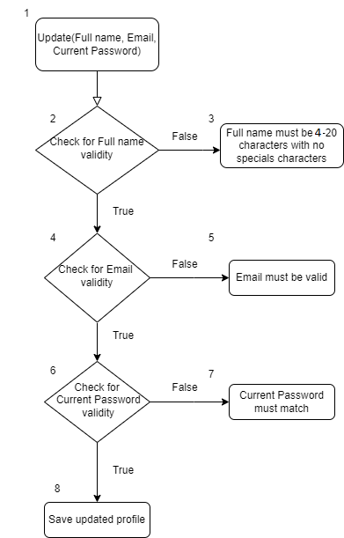

**Test case**

1. The user creates an account with all fields being valid.
2. The user enters an invalid full name (uses a special character or uses under 4 characters or over 20 characters / leaves the field empty).
3. The user inputs a valid name but an invalid email (or leaves the field empty).
4. The user inputs a valid name and email but fails to input the correct current password into the “Current Password”.

**Execution paths**

1. 1, 2, 4, 6, 8
2. 1, 2, 3
3. 1, 2, 4, 5
4. 1, 2, 4, 6, 7

**Cyclomatic Complexity**

[Edges - Nodes] + 2 = [7 - 5] + 2 = 4

[Conditions] + 1 = 3 + 1 = 4

**B) Black Box Testing**

**Test case 1: Creating an Account**

According to our functional requirements, to create an account, the application must accept a name, valid email, and password when a user registers. The email should not be in use by other users as well. To do black box testing on this function, we tested with multiple inputs and noted the results. According to our functional requirements, the application must reject any registration with missing field information, badly formatted email, emails that are already in use and invalid password inputs.

**Equivalence class**

|  |  |  |
| --- | --- | --- |
| **Input data** | **Valid** | **Invalid** |
| Email | Any valid email (that has not been used before) | Empty or badly formatted email, such as inputs without ‘@’. Emails that have been used before. |
| Full Name | Any string input between 4 to 20 characters long with no numerical & special characters. | String input with less than 4 characters or more than 20 characters or contains numerical & special characters. |
| Password | Any string input between 8 to 24 characters long and includes at least an uppercase letter, a lowercase letter, a number and a special character | String input with less than 8 characters or more than 24 characters or does not contain an uppercase letter or a lowercase letter or a number or a special character |
| Confirm Password | Same input as the user entered in “Password” | Any input other than what the user input in “Password” |

**Test Cases**

|  |  |  |  |
| --- | --- | --- | --- |
| **Test Cases** | **Inputs** | **Expected Results (Oracle)** | **Actual Results (Log)** |
| Case 1: Correct input details | **“**timlee@gmail.com”  “Tim Lee”  “Password123!”  “Password123!” | Account created successfully! Please check your email inbox for a verification email. | Account created successfully! Please check your email inbox for a verification email. |
| Case 2: Badly formatted email without ‘@’ | “timleegmail.com”  “Tim Lee”  “Password123!”  “Password123!” | Account creation unsuccessful | Account creation unsuccessful |
| Case 3: Fullname has less than 4 characters | “[timlee@gmail.com](mailto:timlee@gmail.com)”  “Tim”  “Password123!”  “Password123!” | Account creation unsuccessful | Account creation unsuccessful |
| Case 4: Fullname contains numerical/special characters | “[timlee@gmail.com](mailto:timlee@gmail.com)”  “Tim Lee1!”  “Password123!”  “Password123!” | Account creation unsuccessful | Account creation unsuccessful |
| Case 5: Password has less than 8 characters | **“**timlee@gmail.com”  “Tim Lee”  “Passw”  “Passw” | Account creation unsuccessful | Account creation unsuccessful |
| Case 5: “Confirm Password” is not the same as ”Password” | **“**timlee@gmail.com”  “Tim Lee”  “Password123!”  “Passw0rd122” | Account creation unsuccessful | Account creation unsuccessful |
| Case 6: Password does not contain special character | **“**timlee@gmail.com”  “Tim Lee”  “Password123”  “Password123!” | Account creation unsuccessful | Account creation unsuccessful |
| Case 7: All the details not filled in | **“**timlee@gmail.com”  “”  “Password123”  “” | Account creation unsuccessful | Account creation unsuccessful |

**Test case 2: Log-in Function**

According to our functional requirements, for the users to login successfully, users have to key in a valid email address and the correct password. To do black box testing on this function, we tested with multiple inputs and noted the results. According to our functional requirements, the application must reject any login attempts with badly formatted email, invalid email, or incorrect passwords.

**Equivalence class**

|  |  |  |
| --- | --- | --- |
| **Input Data** | **Valid** | **Invalid** |
| email | Any valid email that has already been registered and verified | Empty, badly formatted email or email that has not been registered or email that has not been verified |
| password | The password corresponding to the registered email | Any other string input other than the password corresponding to the registered email |

**Test Case**

|  |  |  |  |
| --- | --- | --- | --- |
| **Test Cases** | **Inputs** | **Expected Results (Oracle)** | **Actual Results (Log)** |
| Case 1: Correct Login Details with verified email | **“**timlee@gmail.com”  “Password123!” | Logged in successfully | Logged in successfully |
| Case 2: Unregistered email | “[john@gmail.com](mailto:john@gmail.com)”  “pw1234Wd” | Error signing in. Please check your email and password. | Error signing in. Please check your email and password. |
| Case 3: Badly formatted email (e.g.: without ‘@’) | **“**timleegmail.com”  “Password123!” | Error signing in. Please check your email and password. | Error signing in. Please check your email and password. |
| Case 4: Wrong password with missing characters | **“**timlee@gmail.com”  “Passrd123!” | Error signing in. Please check your email and password. | Error signing in. Please check your email and password. |
| Case 5: Wrong password with wrong capitalisation | **“**timlee@gmail.com”  “PASSword123!” | Error signing in. Please check your email and password. | Error signing in. Please check your email and password. |
| Case 6: Email registered but not verified by user | “[kevin@gmail.com](mailto:kevin@gmail.com)”  “Password123!” | Your email is not verified. Please check your email inbox for a verification email. | Your email is not verified. Please check your email inbox for a verification email. |
| Case 7: Empty email and password | “”  “” | Error signing in. Please check your email and password. | Error signing in. Please check your email and password. |

**Test case 3: Edit your account**

According to our functional requirements, users are able to edit their name and email address. The user needs to enter current password to update the changes. The application must accept a valid email and the email should not be in use by other users as well. To do black box testing on this function, we tested with multiple inputs and noted the results. According to our functional requirements, the application must reject any change attempts with badly formatted email, emails that are already in use or wrong password.

**Equivalence class**

|  |  |  |
| --- | --- | --- |
| **Input Data** | **Valid** | **Invalid** |
| Full Name | Any string between 4 and 20 characters with no special characters | Any string smaller than 4 characters or longer than 20 characters or contains a special character |
| email | Current email address or any valid new email id that does not already have an account | Badly formatted email or emails which already have an account |
| Current Password | Corresponding password to the account | Any string other than the corresponding password to the account |

**Test Cases**

|  |  |  |  |
| --- | --- | --- | --- |
| **Test Cases** | **Inputs** | **Expected Results (Oracle)** | **Actual Results (Log)** |
| Case 1: Full name, email id registered to the account and correct password is entered | “Tim Lee”  **“**timlee@gmail.com”  “Password123!” | Account updated successfully | Account updated successfully |
| Case: Different full name, email id registered to the account and correct password is entered | “Patrick”  **“**timlee@gmail.com”  “Password123!” | Account updated successfully | Account updated successfully |
| Case: Full name, correctly formatted new email which have not been previously registered and correct password is entered | “Tim Lee”  **“**timlee1234@gmail.com”  “Password123!” | Account updated successfully | Account updated successfully |
| Case: Full name, correctly formatted new email which has already been registered and correct password is entered. [Assumption: [kevin@gmail.com](mailto:kevin@gmail.com) is already registered with myPantry] | “Tim Lee”  **“**kevin@gmail.com”  “Password123!” | This email is already in use, please use another email. | This email is already in use, please use another email. |
| Full name, wrongly formatted email id registered to the account and correct password is entered | “Tim Lee”  **“**timlee@gmail”  “Password123!” | Email must be a valid email. | Email must be a valid email. |
| Case: Full name, email id registered to the account and wrong password is entered | “Tim Lee”  **“**timlee@gmail.com”  “Password1111!” | An error occurred. Please try again. | An error occurred. Please try again. |